Formatting Guidelines for Authors Submitting Papers to ICOP 2024
Author One, Author Two & Author Three
Company Name, City, Province/State, Country
Author Four & Author Five
Department of XX – University of YY, City, Province/State, Country

Abstract
Conference proceedings papers are initially accepted based on the abstract submitted. In order to format your paper correctly, replace this text with your abstract. You may modify your abstract from the version originally submitted as long as the key points remain unchanged. The text in this section will run the width of both columns. The style used is ICOP abstract. The abstract should concisely report the aims and outcomes of your research. Abstracts should be no more than 250 words. Abstracts longer than 250 words may be rejected. Referencing published papers is inappropriate in an abstract. All manuscripts must be prepared electronically and submitted in accordance with the following instructions using the online submission feature provided on the conference website.

1 Paper Preparation Guidelines
These instructions have been created using the technical paper template to illustrate the correct format for the preparation of papers. The template is available on the submission page of the conference website.
Papers must be submitted in English and free of spelling and grammar errors. The author is responsible for checking their paper for proper language use prior to submission.
This document uses boldface and underlining for emphasis, but such text enhancements should not be used in the paper.

1.1 Publication Quality and Uniformity
To ensure publication quality and uniformity, the following guidelines are intended to assist authors in preparing their papers for ICOP2024. The best way to ensure your document follows the guidelines is to use the template provided on the submission page of the conference website. Your paper will be rejected if there are abundant spelling/grammar errors or if these guidelines are not followed.

1.2 Required Registration
All presenting authors must register as a full conference delegate (or student if applicable) to submit a final paper. This must be done on the conference website.

1.3 Draft and Final Submissions
Draft papers must be submitted electronically by using this template via the online submission feature on the conference website – emailed submissions will not be accepted.
Final papers must be submitted electronically according to the ‘ICOP2024 Final Paper Instructions’ via the online submission feature on the conference website – emailed submissions will not be accepted. Please ensure that your manuscript meets these submission guidelines before submitting. Do not submit your file as a PDF as this limits the ability of the technical committee to correct any simple formatting errors. All documents will be converted to PDF files at the proceedings’ production stage.

1.4 Length
The normal length of a complete paper including title, abstracts, text, figures, photographs, tables, acknowledgements, and references is SIX (6) to EIGHT (8) pages. Papers longer than eight (8) pages in length will be accepted at the discretion of the Technical Committee.

1.5 Font
All text must be in 9-point Arial font with the following exceptions:
- The title must be in 14-point bold. Bold font face should not be used anywhere else in the paper.
- Authors’ names should be in 10-point Arial font.
- The affiliation, city, province/state and country must be in 10-point Arial Italics font.
- Section Headings must be in 10-point Arial font.
- Table text must be in 8-point Arial font.
- Use Italics font for ‘quoted text’, and to identify the source in the list of references.

1.6 Page Size and Margins
The supplied MS Word template has been formatted per this document. If you are not using MS Word, please select “letter” paper size (215.9 mm by 279.4 mm / 8½ inches by 11 inches) and portrait orientation – A4 format is not acceptable. Please set your page for the following margin dimensions: top – 1 inch, bottom – 1 inch, left – 19 mm / 0.75 inch, right – 19 mm / 0.75 inch, and gutter – 6.35 mm / 0.25 inch.

1.7 Page Numbers
Do not change page numbers or add headers or footers. Final page numbers, headers and footers will be added when the proceedings are assembled.

1.8 Spacing and Indenting
All text elements should be single-spaced.
Paragraph text in a section is not indented (use style ICOP normal). There should be no line spacing between paragraphs. The text should be right and left-justified.
By using ICOP normal for formatting paragraph text spacing is applied before and after paragraphs. Do not modify any of the ICOP style formats.
Leave one (1) open line between equations and text, and between successive equations. Leave one (1) open line between the body of the text and figures or tables (including captions).
If there is a discrepancy between the template and these instructions, the instructions take precedence.

1.9 Conference Logo
The conference logo has been placed at the top right corner of the first page (only). Do not move or adjust the size of the logo.

1.10 Title/Author(s)
Replace the full paper title at the top of the first page with your own. Text is Arial 14-point bold, sentence case and left justified. Use the paragraph style ICOP paper title; paragraph formatting has been applied.
Replace the author’s name(s) below the paper title. Authors from the same institution may be grouped together. Replace affiliation and country text below the author names.
Use style ICOP author names and ICOP author affiliation to format these lines. Paragraph formatting has been applied to each style.

1.11 Abstracts
Each paper must begin with the abstract. The total word length of the abstract should not exceed 250 words.
Replace the body text of the abstract. The abstract should run the width of both columns. Use style ICOP abstract normal; paragraph and font have been formatted.
A reference to a published paper or report in the abstract is inappropriate.

1.12 Number Headings
Within the paper, headings are numbered as follows:

1 Primary Heading: ICOP Heading 1

1.1 Secondary Heading: ICOP Heading 2

1.1.1 Tertiary Heading: ICOP Heading 3

1.13 Tables
Number tables consecutively in the order of appearance and locate them close to the first reference to them in the text. Refer to tables as Table 1 or Tables 1 and 2, in the body of the text. Avoid abbreviations in column headings (other than units). Indicate units in the line immediately below the heading.
Type the caption above the table to the same width as the table; use style ICOP table caption.
Use the same table format as it appears in the Canadian Geotechnical Journal. Tables should be the same width as the column text. Use the following example for the format of the table. Use style ICOP table text.

Table 1. Characteristics of tested soils.
Characteristics (%) | Vancouver | Ottawa
Organic matter | 0 | 1
Water content | 40 | 60
Liquid limit | 22 | 44
Plastic limit | 15 | 18
Sand | 35 | 8
Silt | 45 | 44
Clay | 20 | 48

1.14 Equations, Formulas, Symbols and Units
Type equations and formulas from the left of the column (do not center in the column) and number them consecutively. Equation numbers should be placed flush at the right column margin in square brackets.
Refer to equations in the body of the text by these numbers (e.g., "Eq. 1" or "Equation 1 shows..."). Symbols should conform to those recommended by the Metric Subcommittee of the Canadian Geotechnical Society (see Canadian Geotechnical Journal 1980, 17:89-96).
Example of an equation:

τ = σ tan φ + c [1]

1.15 Figures/Illustrations
All illustrations must be embedded in the document using “in line with text” option. Please resize the inserted object to the desired final dimensions before inserting it in the document to minimize the file size of the final document.
Preferred figures and illustration file formats to insert are .png and .svg.
Please number illustrations (whether drawings or photographs) consecutively in the order of appearance and refer to them as Figure 1, Figures 2 to 4, etc.
Illustrations may be two (2) columns wide or one (1) column wide. Do not place illustrations sideways on a page; however, if this cannot be avoided, no other text should appear on that page.
Under no circumstance is it acceptable to change the orientation of any page to “Landscape” to accommodate a figure.
Figures may be in colour since papers will only be published in electronic format.
Lettering in figures should be approximately the same size as the text with a minimum of 2 mm. Lines should preferably be 0.2 mm thick. Captions should be placed immediately below the illustration; use style ICOP figure caption.

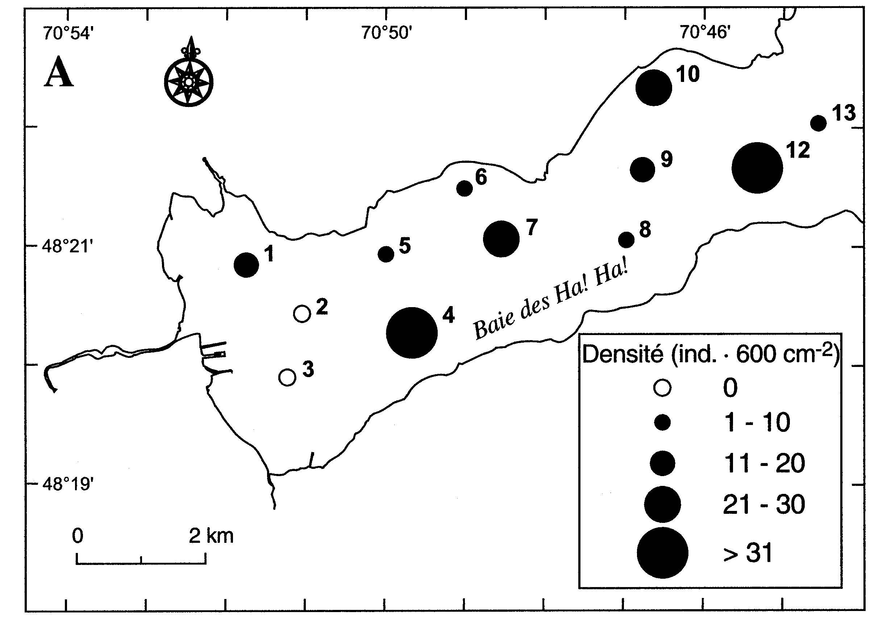
Figure 1. Spatial distribution of the macro-benthic organisms (from Pelletier et al. 1999).

1.16 References
The conference will follow the current practice of the Canadian Geotechnical Journal, i.e. Harvard citation style for references.
References are included in the 8p. limit.
Within the body of the text, references should be made in parenthesis with the author’s surname(s) and the year of publication such as “(Seed et al. 1977)” or “According to Seed et al. (1977), …”
At the end of the paper, list all references in alphabetical order of authors’ names. The first line of each entry in the reference list should not be indented: use style ICOP reference. Do not leave an open line between references.
References that are not publicly available, such as internal reports, or manuscript in preparation should not be cited.
Format for books is:
Last name, Initials. Year. Book title, Publisher, City, State/Province, Country (of publisher).
For example:
Terzaghi, K., and Peck, R.B. 1987. Soil Mechanics in Engineering Practice, 2nd ed., McGraw Hill, New York, NY, USA.
Format for journal papers is:
Last name, Initials. Year. Article title, Name of Journal, volume number (issue number) in Arabic numerals, pages. doi. For example:
Ingold, T.S., and Miller, K.S. 1983. Drained Axisymmetric Loading of Reinforced Clay, Journal of Geotechnical Engineering, 109(7): 883-898. doi:10.1061/(ASCE) 0733-9410(1983)109:7(883).
Format for conference papers is:
Last name, Initials. Year. Article title, In Name of Conference, Publisher, City, State/Province and Country where the conference took place, volume number in Arabic numerals: pages.
For example:
Leshchinsky, D., and Perry, E.B. 1987. A Design Procedure for Geotextile Reinforced Walls, In Geosynthetics ‘87, IFAI, New Orleans, LA, USA, 1: 95-107.

2 Manuscript Structure
The ICOP2024 Technical Program Committee expects that the manuscript structure will follow the usual scientific approach. On an indicative basis, the structure should include the following elements in this order:
- Introduction (rationale, literature review, problematic, study site, objectives)
- Methodology
- Results
- Discussion
- Conclusions
- Acknowledgements
- References

3 Clearances
All authors are responsible for obtaining written permission to present the project or subject matter in their papers from all clients, owners, or others who commissioned the work.
The ICOP2024 National Organizing Committee and the Canadian Permafrost Association assume that you have obtained the proper permission(s) as well as the permission of all coauthors. The ICOP2024 National Organizing Committee and the Canadian Permafrost Association assume no liability for failure by the author(s) to gain proper permission.
When the final manuscript is submitted, the corresponding author must read and accept, by checking a box, the copyright release and publication authorization.

4 Copyrighted Material
If a figure, table or photograph has been published previously, authors must obtain written approval from the original publisher for it to be reprinted in the conference proceedings. The ICOP2024 National Organizing Committee and the Canadian Permafrost Association assume no liability for failure by the author(s) to gain proper approvals.

5 Commercialism
All commercialism must be avoided. Products should be defined by their properties. Product names can only be used once within the paper and only where they are associated with the definition of the properties. Papers that do not conform will be rejected.
Providing an acknowledgement of sponsorship at the end of a paper is both appropriate and acceptable.

